Game Design Document

Fill up the following document

1. Write the title of your project.

THE CORONA VIRUS HUNTER

1. What is the goal of the game?

The goal of the game is to kill all the corona virus monsters and collect points.

1. Write a brief story of your game.

One day a virus named corona virus crashed their ship on Earth causing

all the virus to spread in the air and attack people but a doctor came and

said to all the people that I have the cure of this virus thus he fought and defeated the virus

1. Which are the playing characters of this game?

* Playing characters are the ones who respond to the user based on the input from the user.
* Cars, monkeys, dinos, wizards, etc., are the playing characters in the game.

|  |  |  |
| --- | --- | --- |
| Number | Character Name | What can this character do? |
| 1 | DOCTOR | Walk,jump,shoot |
| 2 |  |  |
| 3 |  |  |
| 4 |  |  |
| 5 |  |  |
| 6 |  |  |
| 7 |  |  |
| 8 |  |  |

1. Which are the Non-Playing Characters of this game?

* Non-Playing characters are the ones that don't have an action or behavior when the user interacts with the game.
* Hurdles, stones, bananas, coins, etc., are non-playing characters in the game.

|  |  |  |
| --- | --- | --- |
| Number | Character Name | What can this character do? |
| 1 |  |  |
| 2 | VIRUS | Move and shoot |
| 3 |  |  |
| 4 |  |  |
| 5 |  |  |
| 6 |  |  |
| 7 |  |  |
| 8 |  |  |

1. Draw your imagination of this game. What does this game look like?

* Draw the game either on your computer or on paper.
* Add images of the game scenes to show each of the playing and non-playing characters at least once.

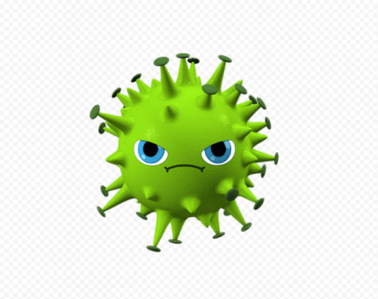 

1. How do you plan to make your game engaging?

Ans.) I plan to make my game engaging by adding all the game elements and

by making the NPC’s a bit hard to defeat!